Algebra 1: Unit 9, Lesson 6

- Sofia solved the equation, $x^{2}-8x-43=0$, by completing the square. Some of her work is shown. Fill the blanks with the steps that complete Sofia’s work.
$$x^{2}-8x-43=0 \\ {(x}^{2}-8x)-43=0 \\ {(x}^{2}-8x+16)-43-16=0 \\ {(x- ________ )}^{2}-43-16=0$$
$$4$$

- Complete the missing step in the table to show the next step when solving by completing the square.
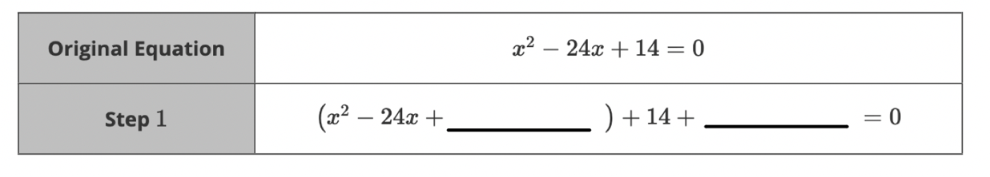
$144$ and $-144$

- Fill the blank with the step that completes the missing step to complete the square.
$$x^{2}-10x-38=0 \\ {(x}^{2}-10x)-38=0 \\ {(x}^{2}-10x+_________)-38-25=0 \\ {(x-5 )}^{2}-63=0$$
$$25$$

